Questions Week 4 Sjoerd Herlaar

* 1. Bing maps does not show any residential buildings, it only shows the outskirts of buildings like museums and churches. This makes it a little hard to search for something you might be looking for. Especially considering what Yahoo Maps does.

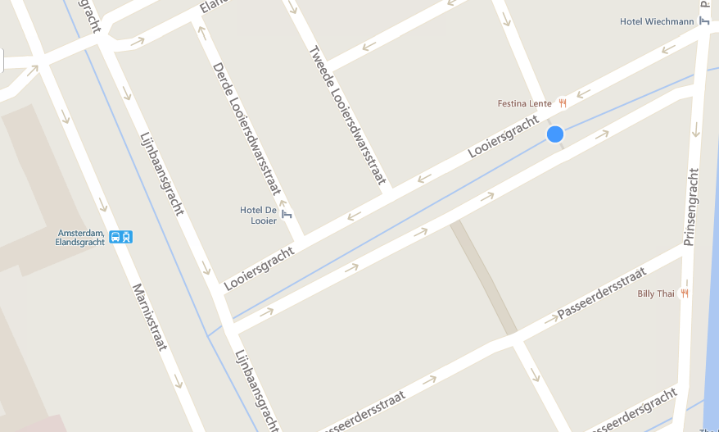

Yahoo maps shows many residential buildings as on top of many other buildings, this makes it a lot easier to find specific buildings. Some of the address numbers are even placed around the entry of the very building.

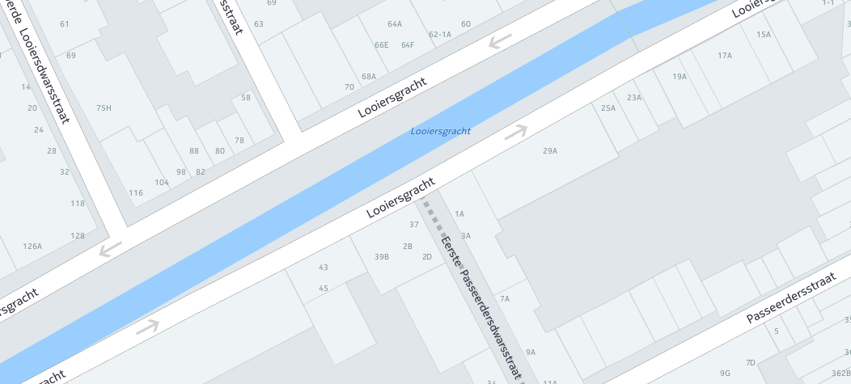

* 1. Since I exclusively use Google Maps, I decided to use Yahoo Maps and Bing Maps. Both maps were supposed to give me the quickest route from the Amsterdam city center to the Rotterdam city center.   
     Both services gave me roughly the same route, though there was a slight difference in the time needed to get there. Something that immediately struck me is that it looks like Bing is not taking rush hour or traffic jams into account. Its line was perfectly purple whilst Yahoo seemed to show where the possibility of traffic jams would be bigger.   
     Both routelines seem to be translucent, which makes it slightly easier to see where crossroads are. Even though Yahoo also gives information about the traffic, I found Bing to be more gentle on the eyes because of its simplicity.

Yahoo Maps

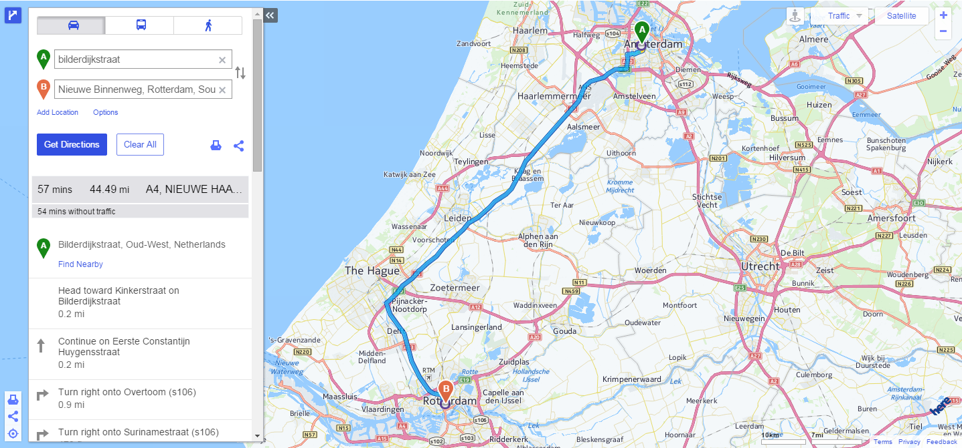

Bing Maps

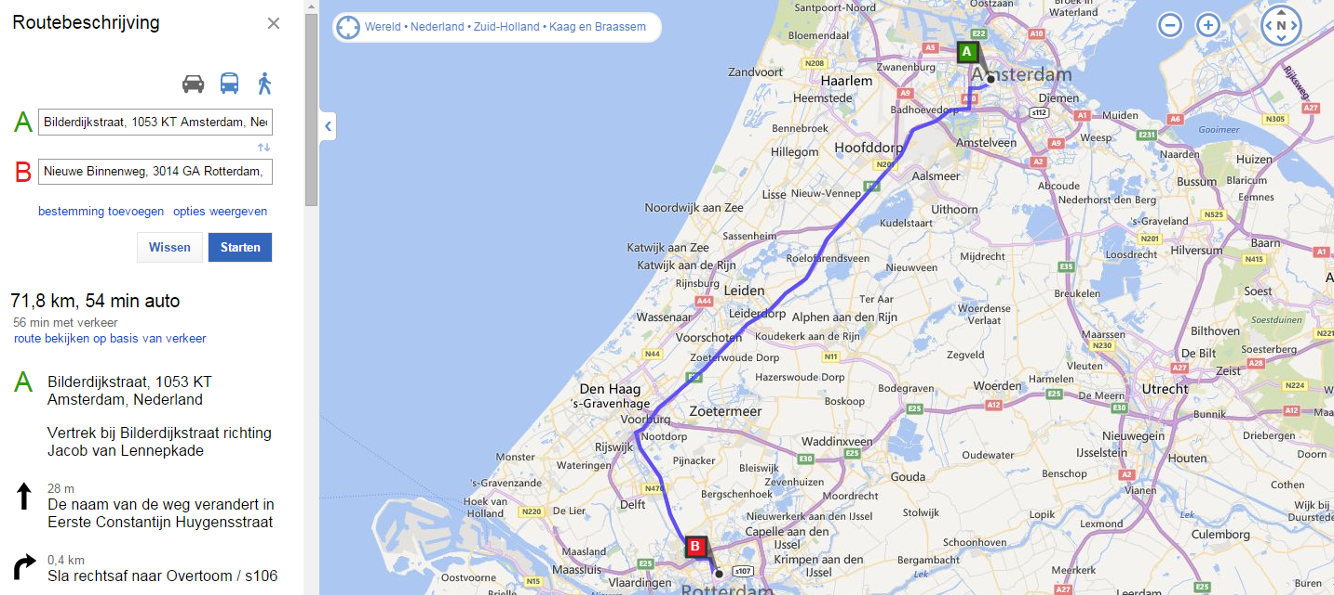

* 1. In my opinion, Yahoo Maps does a better job at visualizing then Bing Maps even though I like the aesthetics of Bing more. Yahoo shows higher detail in the more dense city centers than Bing and also shows things like traffic jams when Bing does not. Even though Yahoo uses the dreaded “Rainbow Colour Map” it only uses three colours to show how bad it actually is. Since red is naturally linked to problems and negativity, I think the message is delivered in a clear and simple way. This is why I think Yahoo pulls of a better job than Bing.

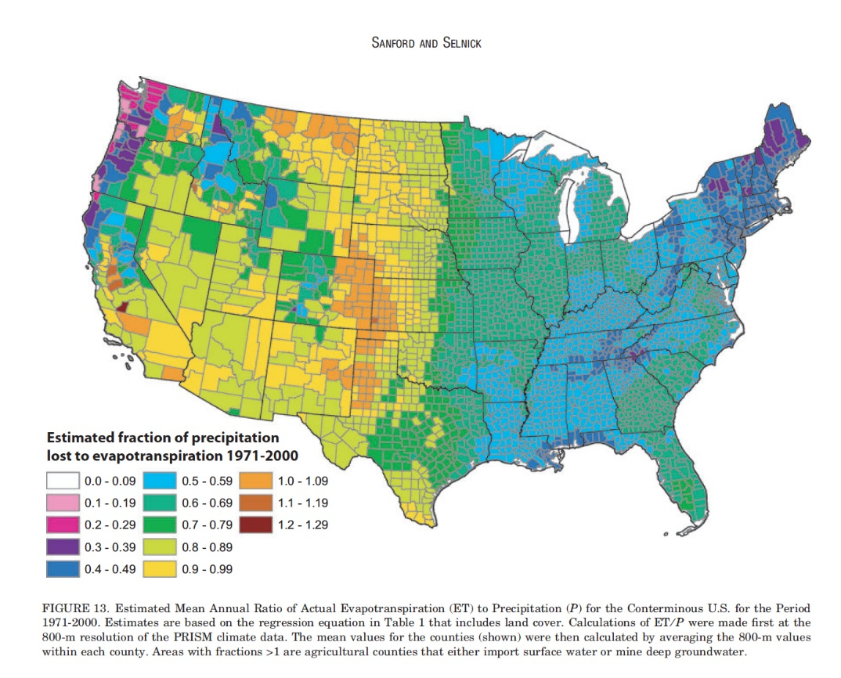

https://eagereyes.org/wp-content/uploads/2013/07/evapotranspiration-map.jpg

* 1. The Rainbow Colour Map shown above shows the relation between the mean evaporation of water and different areas of the US. The target audience can be anything from farmers to US citizens looking for a climate they like to live in. The idea for a gradient scheme is suited for the graph shown here, the problem arises when the rainbow colour scheme is used. As Rogowitz, Treinish and Bryson mentioned in their article, the problem with rainbow colour schemes is that readers have a hard time connecting certain colours with a value. A legend can partly solve that problem but it will still give readers a hard time. If a gradient was used, everything would have been more clear, albeit it might have looked a little less exciting.
  2. One of the biggest problems with this specific map is the fact that is has 13 different gradients. This will create a problem since more gradients will affect the difference in colour between de gradients. Five to seven different gradients is normal, especially for maps and so one simple solution is to lessen the amount of different colours needed. Since green is the colour that has the most indistinguishable gradients, I chose to use green. It is also colourblind safe, which is an extra feat. Unfortunately, this means that only nine to ten different colours can be used without losing clarity.



http://colorbrewer2.org/